Hem Stitched and Drawn Thread Bookmarks

Catherine Jordan
Catherine’s Designs™
3435 Pleasants Road
Powhatan, VA 23139
jordancd@verizon.net
www.CatherinesDesigns.net

Introduction

Hem stitching is a pulled thread embroidery technique for finishing edges of fabric neatly and securely. Drawn thread embroidery involves cutting and removing threads from a fabric and securing and embellishing the opened area. This project gives the directions to make a bookmark with a fringed hem stitch on one end and a turned hem stitched edge on the other end. One or more sections in the middle of the bookmark can be embellished with drawn thread techniques with a variety of options for embellishing the openings. Additionally, several reversible techniques are illustrated that can be added for embellishment towards the top of the bookmark.

These directions may be copied by EGA members. The bookmarks shown are worked on 1” wide linen banding (28 count); white banding may be available at your local needlework store. White and rainbow over dyed banding are available from my web site.

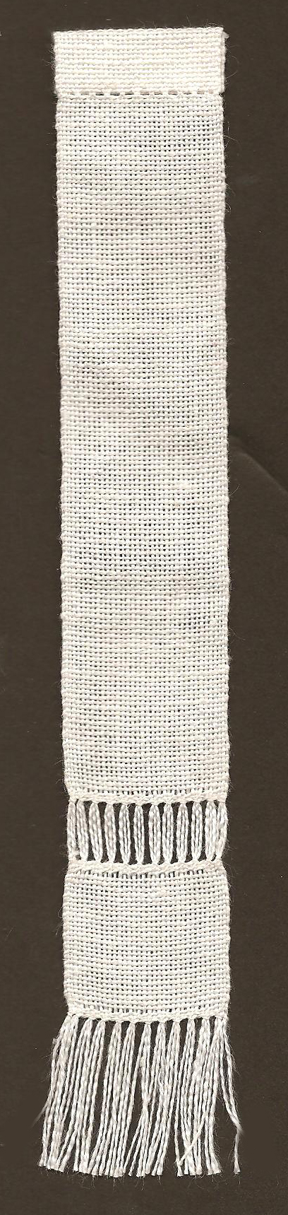 | Supplies Needed  - 9” length of 1” wide linen banding  - #26 tapestry needle  - Embroidery floss – your choice of color.  - Sewing thread to match banding for hem stitching  Finished bookmarks
  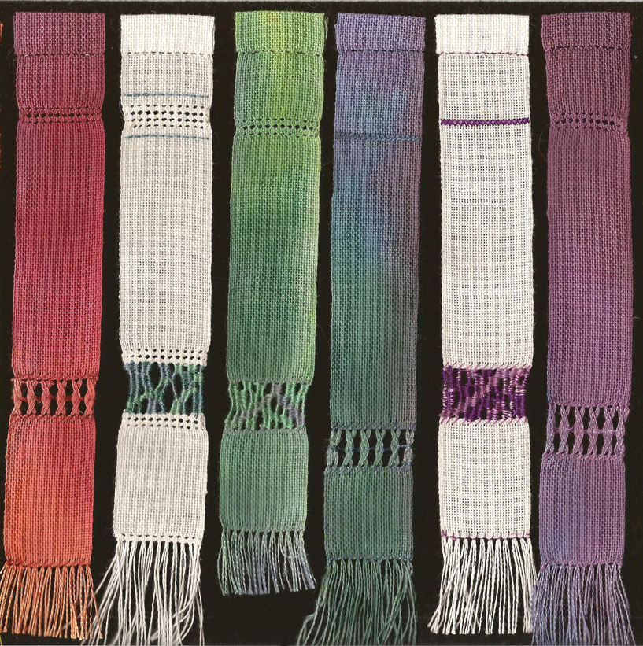 | Hem stitch folded edge  Reversible embellishments  Drawn thread opening  Hem stitch fringed edge
Bookmark shown with top hem stitch folded edge,
middle section opened, and bottom hem stitch fringed edge.
Hem Stitching Basics

Hem stitching involves 2 steps:

Step 1: The needle passes under a group of threads (needle is horizontal shown on the left in each diagram below) scooping them up, pulling and knotting them together.

Step 2: The needle (held vertically shown on the right in each diagram below) bites downward into the fabric to secure the knot.

Right handed directions Left handed directions
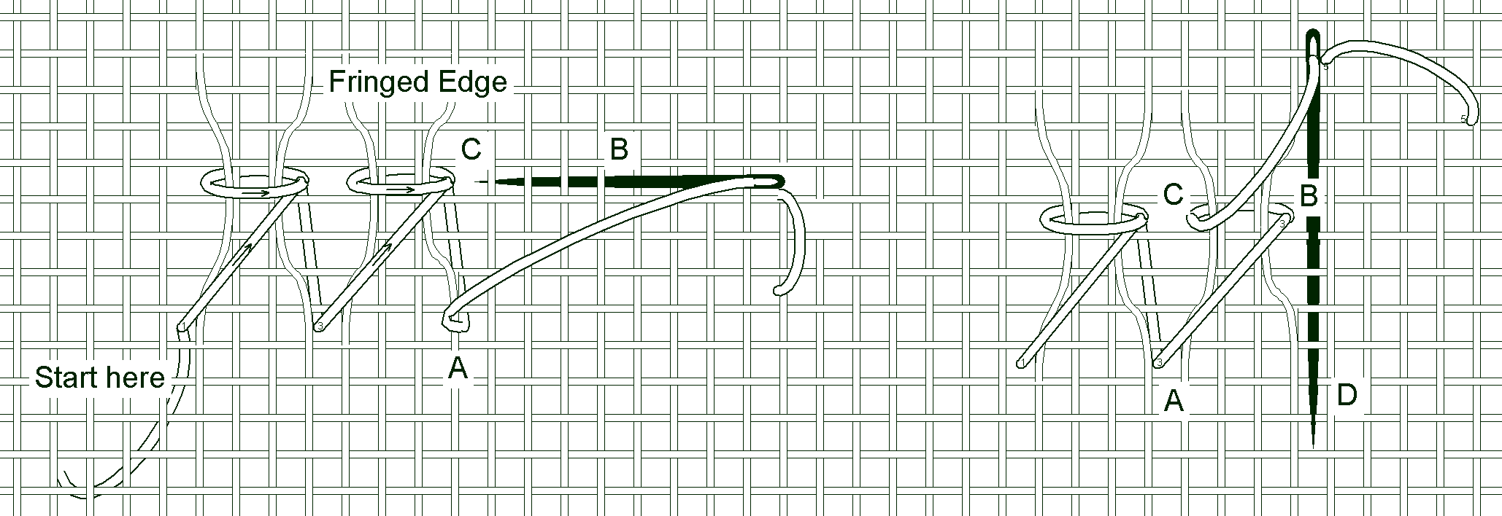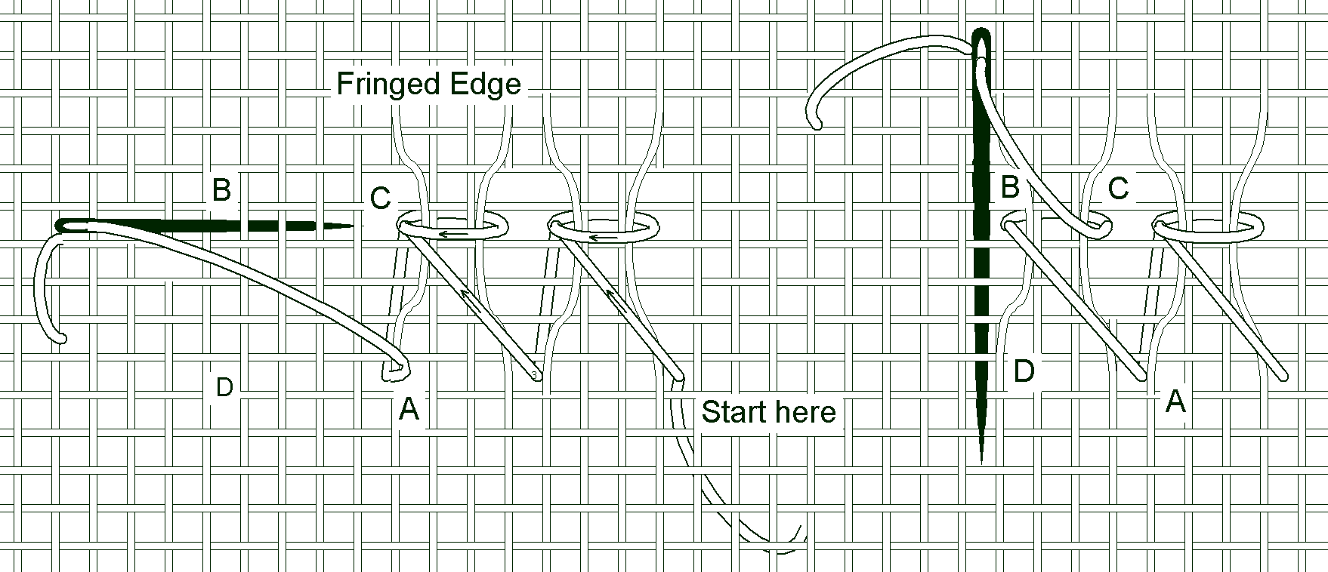

Step 1: Scoop | Step 2: Bite | Step 1: Scoop | Step 2: Bite
Up at A  Down at B  Up at C | Down at B  Up at D | Up at A  Down at B  Up at C | Down at B  Up at D

NOTE: The scooping action forms a knot or loop that must be adjoining the open area to be secured, such as the fringe or drawn thread opening. The biting stitch should go into the body of the fabric away from the open area.

Tips for Hem Stitching

- Hem stitching can be worked over 2, 3 or 4 threads (over 4 threads is shown in the diagram).
- Begin with an “away” waste knot long enough to later thread into a needle and weave into the back of the completed hem stitching.
- Pull stitches tightly to secure the edge.
- This is a pulled thread technique, so the working thread should be pulled until the linen threads are gently pulled together and are touching side-by-side, but not so tight that the linen threads bunch up and cross over each other.
- Do not unravel the fringe or withdraw threads until the hem stitching is completed.
- Begin and end on the back by running the working thread underneath the completed stitches and into the linen fabric.

Beginning the Bookmark

Begin by hem stitching the end that will be the fringed end, being sure to work so that the knots will secure the fringe. Begin about 1 ½” from the tip of the banding. Take the first stitch over 2 threads to secure it tightly and then take another stitch over 3 threads that goes around the outside edge of the banding. If you simply take a large stitch over the edge, the thread can slip down and out of place. This first little stitch locks the first stitch in place. Repeat this little stitch at the end of the row when you are finishing over the edge. Work the hem stitching over 3 threads and down 3 threads.

Place an away waste knot  in the working thread.  Down at A  Up at B  Down at C  Up at D  Down at C  Up at E –around selvage edge  Down at C  Up at F  Continue across | 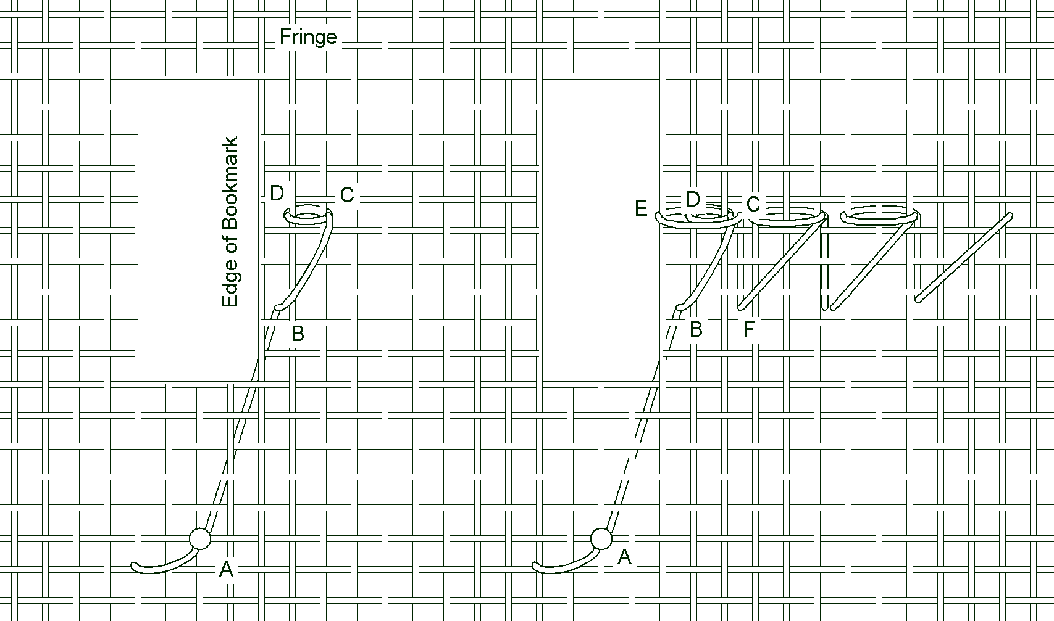

Hem stitching a turned edge

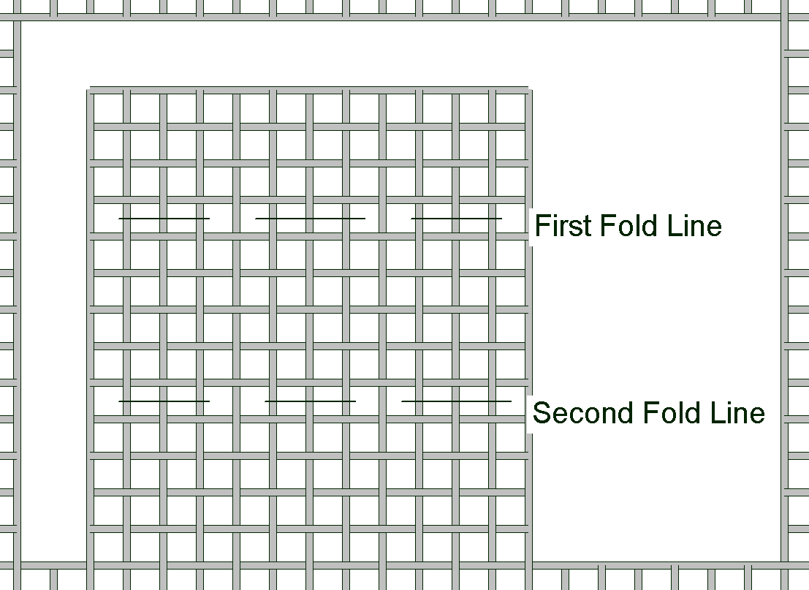 | - On the opposite end of the banding turn the hem toward the back once (First Fold Line) and then fold it again (Second Fold Line). The raw edge will be hidden in the fold and the second fold makes the top of the bookmark.  - Finger press in place.  - Turn your bookmark upside down for the next step. You will be working from the back side.

Working from the wrong or back side, hem stitch gathering 3 threads from the front as you take the scooping stitch and 2 threads from the crease in the hem on the biting stitch.

The biting stitch should not show through on the right side and should not catch any threads on the front. It should go through the threads on the first fold line. | 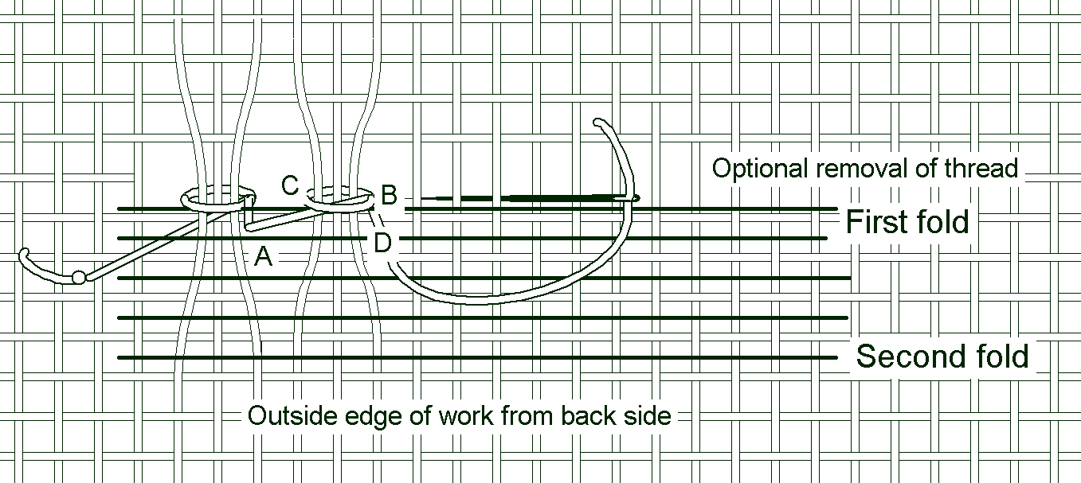

Step 1: Scoop | Step 2: Bite
Up at A  Down at B  Up at C | Down at B  Up at D

Finish your bookmark with one end fringed and one end folded.

Drawn Thread Techniques: Hem Stitched Bands

Work the 2 rows of hem stitching toward the bottom section of the bookmark (see the picture on page 1 for an approximate placement). The size and placement of the opening is your choice.  NOTE: The looped knots secure the opening and the knots group the same vertical threads together | 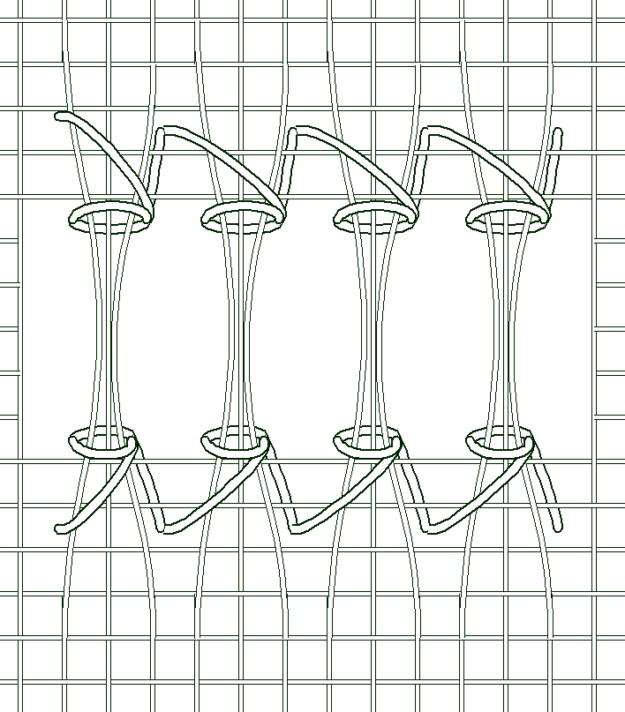 Ladder Hem Stitching
.
Removing the Weft Threads

Once an area had been secured by hem stitching, simply cut the horizontal (weft) threads in the middle of the secured area and pick them out one at a time.

Work one of the following fillers to decorate the warp (vertical threads) that remain in the opening:

Two Warps Inverted

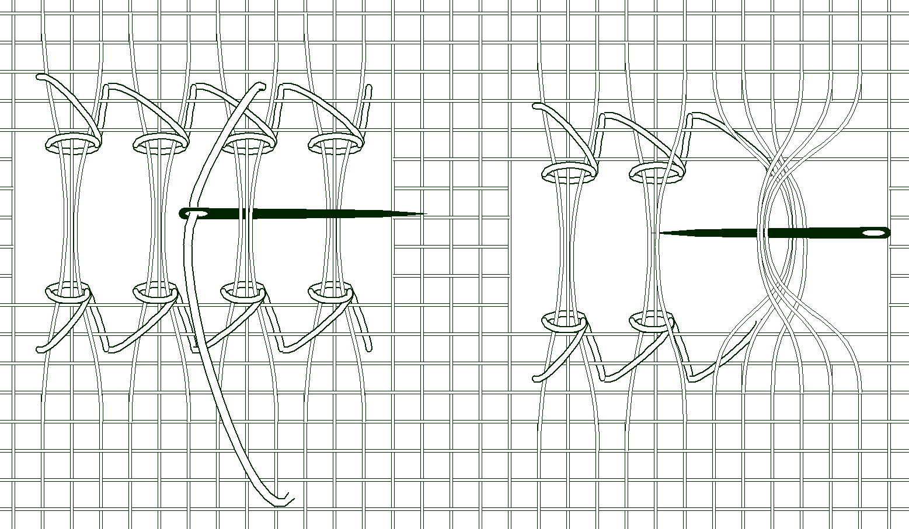 | 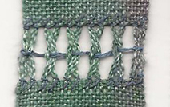

Pass the needle under one group of bundled threads (left) and over the bundle on the right.
Rotate the needle so that it points to the left and the bundles will be inverted. Pull the decorative
thread through and invert the next two bundles. Finish off invisibly in the decorative thread by
weaving the tails in from each side. Use 2-3 plies of floss, perle cotton #8, or silk ribbon.

Needle Weaving

Use 2 plies when needle weaving and wrapping, keeping them side-by-side and not twisted. Begin with an away waste knot that is long enough to be threaded and inserted into the weaving to end invisibly.

The vertical threads (warp) that are left can be woven together to add color to the design:

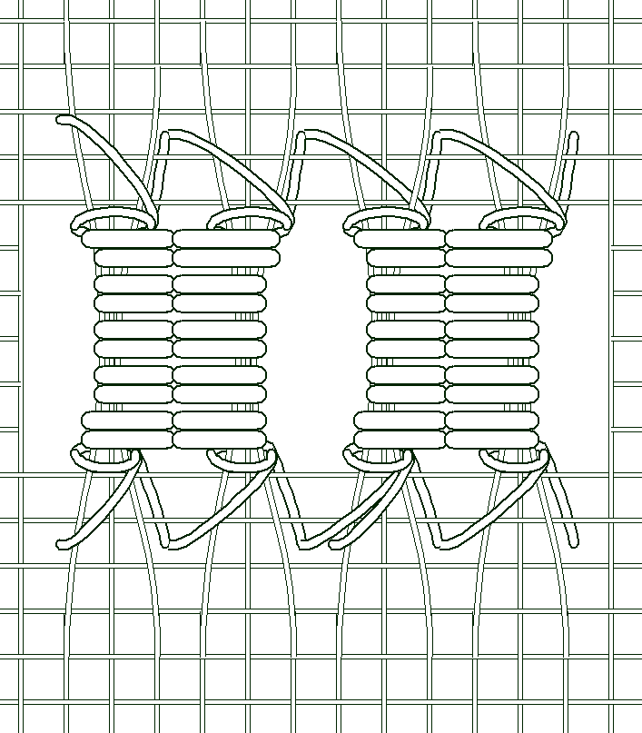 | 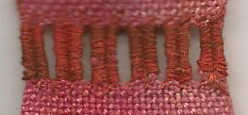

More free-form designs are possible with random weaving. Try to work the weaving in diagonally and then go back and fill in with wrapping. Fill in as much or as little as you like using over dyed threads, multiple colors, or solid color threads.

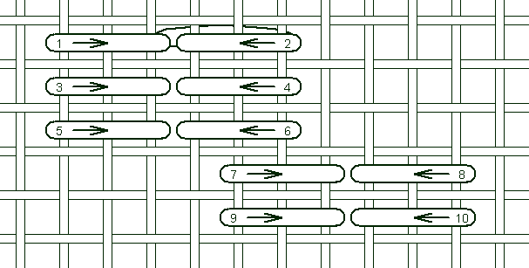  Weaving | 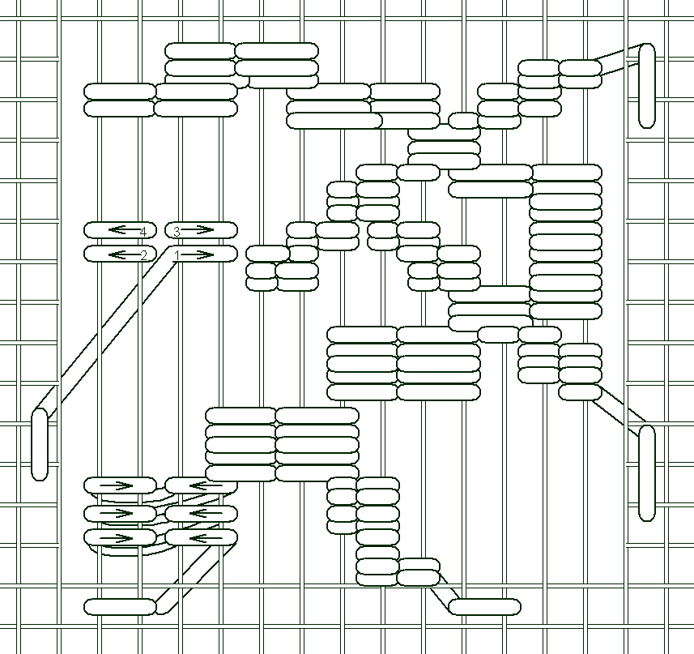  Random weaving | 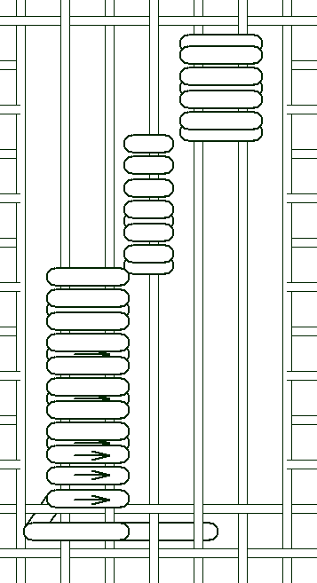  Wrapping

Adding Additional Rows of Reversible Work

Decorative rows of the following reversible stitches can be added toward the top of the bookmark.

Reversible Cross Stitch Rows  Up at A  Down at B  Up at A  Down at C  Up at D  Down at E  Up at D  NOTE: Tiny “over one” quarter stitches (#2 & #5) move you invisibly from one hole to another and are hidden by the longer stitches over 2 threads. | 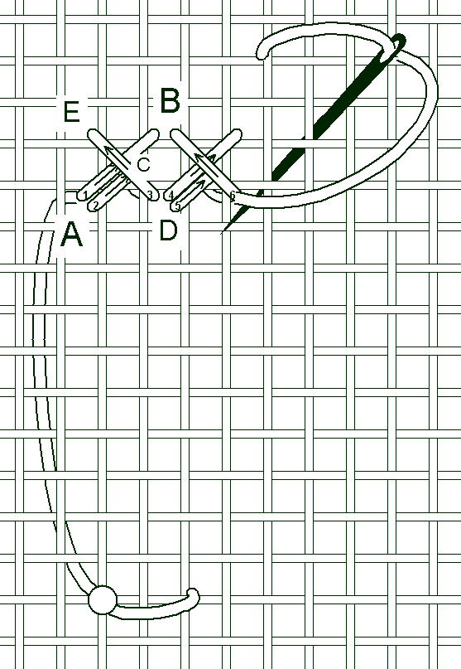
Long Arm Cross Stitch  This stitch is reversible, but it is not the same on both sides. On the front will be a row of overlapping cross stitches and on the back will be a row of vertical bars. | 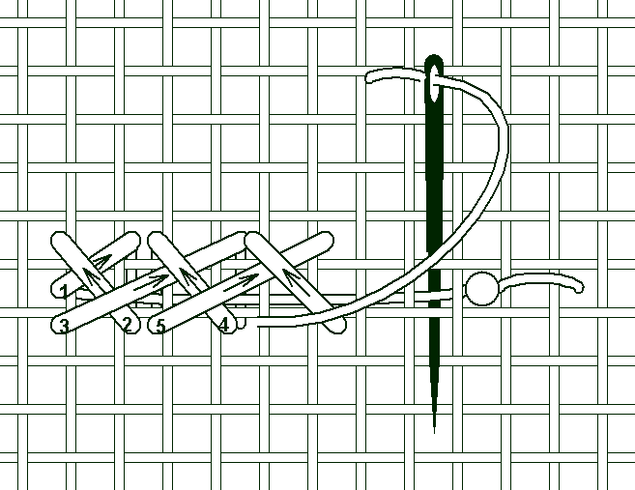

References

Ambuter, Carolyn. The Open Canvas. NY: Workman Publishing, 1982.
Clabburn, Pamela. The Needleworker’s Dictionary. NY: William Marrow & Company, Inc., 1976.
Fanger, Esther, Ida Winckler & Agnete Madsen. Danish Pulled Thread Embroidery. NY:
Dover Publications, 1977.
McNeil, Moyra. Drawn Thread Embroidery. NY: Henry Holt and Company, 1989.
McNeil, Moyra. Pulled Thread Embroidery. NY: Taplinger Publishing Co, 1972.
Mitrofanis, Effie. Needleweaving and Embroidery: Embellished Treasures. China: Sally Milner Publishing Pty Ltd, 2005.

